PAX Unit
02Oct02 – DRD

10.5″

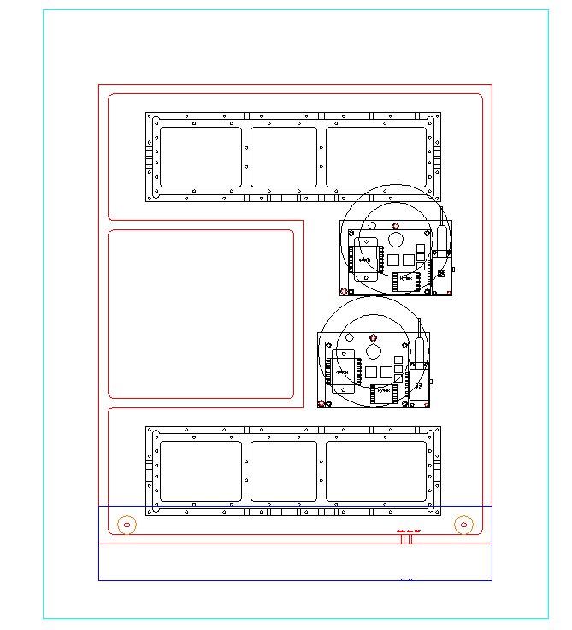

12.25″

Here are three different views of the PAX with the PAM and OTX installed. The other square is for the MCU and regulators, etc. The aqua is the insulation, which will completely surround the PAX (and from which the foyer (in blue) will protrude from the bottom (it is attached with 1″ plastic standoffs in orange, and the insulation is 2″ thick). A channel will be cut in the insulation (and be covered with insulation) to guide the fiber through to the foyer. The exit and entry are through slits in the box near the cover. The fiber will have a sleeve at those points and be RTV’d into position.

